LANE DETECTION BLOCK:

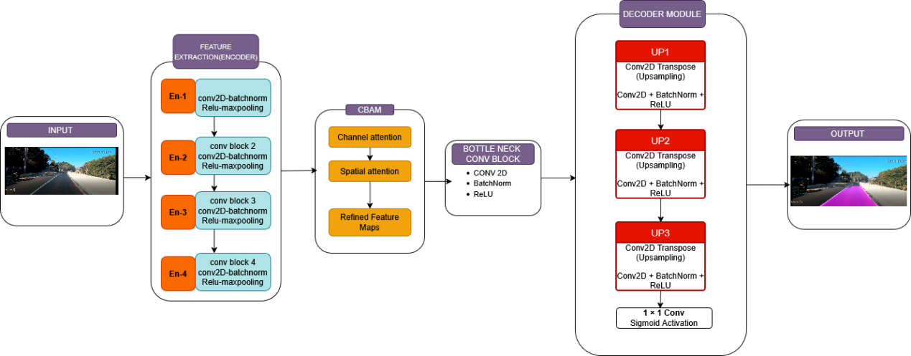

TRAFFIC SIGN DETECTION BLOCK:

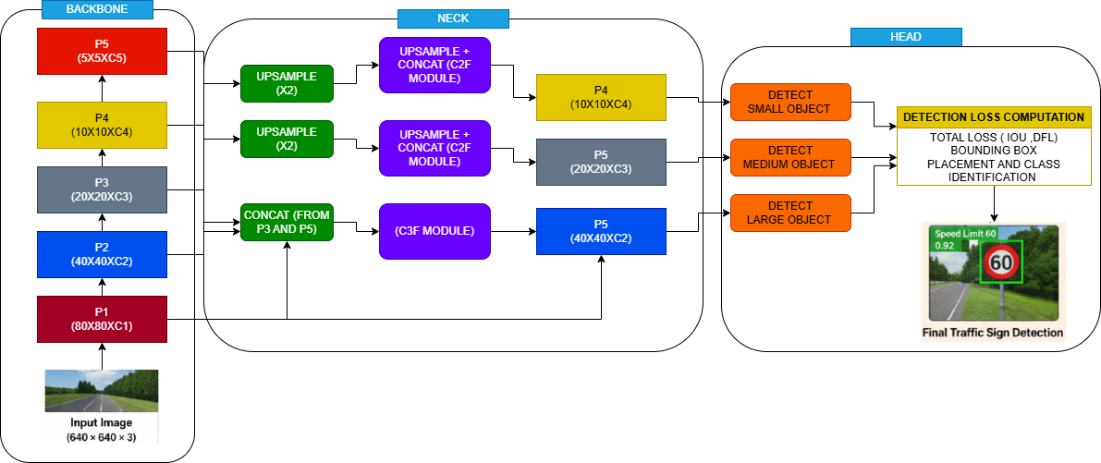

COMBINED BLOCK:

